DRIJEN B.KAVANI

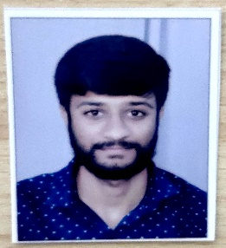
drijenkavani202@gmail.com
9925608594
Gam-vajadi, post-mangnath pipali,
Ta-visavadar/ji-junagadh,visavadar,
Junagadh,gujarat -362130

Objective

To become a successful professional in field of pharmacy and to work in an innovative and competitive world.

Skills

Hardworking
Good communication Ability to take challenges Postive atitude

Languages

GUJARATI
HINDI
ENGLISH
Education
Bachelor of pharmacy, 7.23 CPI
Dr. Subhash Technical campus-GTU
2020 | Junagadh, India
12th science -41.25%,
VISHVGRAM VIDHYAPITH SHAIKSHANIK SANKUL-GHSEB
2016 | Junagadh, India
10th-80.16 %,
VISHVGRAM VIDHYAPITH SHAIKSHANIK SANKUL-GSEB
2014

Professional Experience

JAY AMBE HOSPITAL CHAPRDA (SENIOR PHARMACIST & PURCHASE MANGER)
APRIL2021- JUNE2022
SAVA AAYUSH HOSPITAL-SURENDRANAGAR (SENIOR PHARMACIST & PURCHASE MANGER) JULY2022 – JULY2024
AAYUSH HOSPITAL-(JUNAGADH-SENIOR PHARMACIST & TEAM LEADER) AUG2024 – FEB2026

Projects

Actively participated in GUJCOST sponsored National seminar on various topics.

Participate in pharma quiz event GTU center tachfest.

Declaration

I hereby declare that all the information furnished above is true to the best of my belief.

Interest
Cricket Cooking
Traveling

