CURRICULUM VITAE
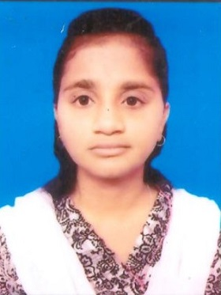

Please affix a
Passport size
photo here

NAME : MOUSUMI GHOSAL
FATHER’S NAME : DURGA CHARAN GHOSAL
DATE OF BIRTH : 10.09.1999
PERMANENT ADDRESS : VILL.:- SRICHANDRAPUR
P.O. :- NITYANANDAPUR
P.S :- GANGAJALGHATI
DIST. :- BANKURA
PIN - 722142(W.B)
CONACT NO. : 07384706976
E-MAIL ADDRESS : mousumi.kalgora1999@gmail.com
NATIONALITY : INDIAN
RELIGION : HINDU
CATEGORY : GENERAL
SEX : FE MALE
LANGUAGES KNOWN : BENGALI, ENGLISH & HINDI

EDUCATIONAL QUALIFICATION (ACADEMIC):-

EXAM. PASSED | BOARD/  UNIVERSITY | YEAR OF PASSING | PERCENTAGE OF MARKS | DIVISION
MADHYAMIK | W.B.B.S.E | 2015 | 90% | 1ST
H.S | W.B.C.H.S.E | 2017 | 76.6% | 1ST
DIPLOMA IN MEDICAL LABORATORY TECHNOLOGY(DMLT) | STATE MEDICAL FACULTY OF WEST BENGAL | 2017 - 2019 | 64.5% | 1ST

EDUCATIONAL QUALIFICATION (TECHNICAL):-

COMPUTER - CITA MULTI RESOURCES COMPUTER CENTER

EXPERIENCE

LAB TECHNOLOGIST
01-08-2020-TO 31-05-2021- VIVEKANANDA HOSPITAL PVT LTD.

- Worked as a lab Technician in Pathology Microbiology Clinical Haematology, Biochemistry.

LAB TECHNOLOGIST

01-06-2021 TO CONTINUE -ASANSOL DISTRICT HOSPITAL

- RTPCR LAB

OBJECTIVE :
Intend to built a career with leading co-operation in hi-tech environment with committed and dedicated people, which will help me to explore myself fully & realize my potential willing to work as a key player in challenging and creative environment.

DECLARATION :- “I HERE BY DECLARE THAT THE ABOVE INFORMATION IS TRUE TO THE BEST OF MY KNOWLEDGE AND BELIEF.”

`
Place :- BANKURA
Date:- 13/08/2021

MOUSUMI GHOSAL

