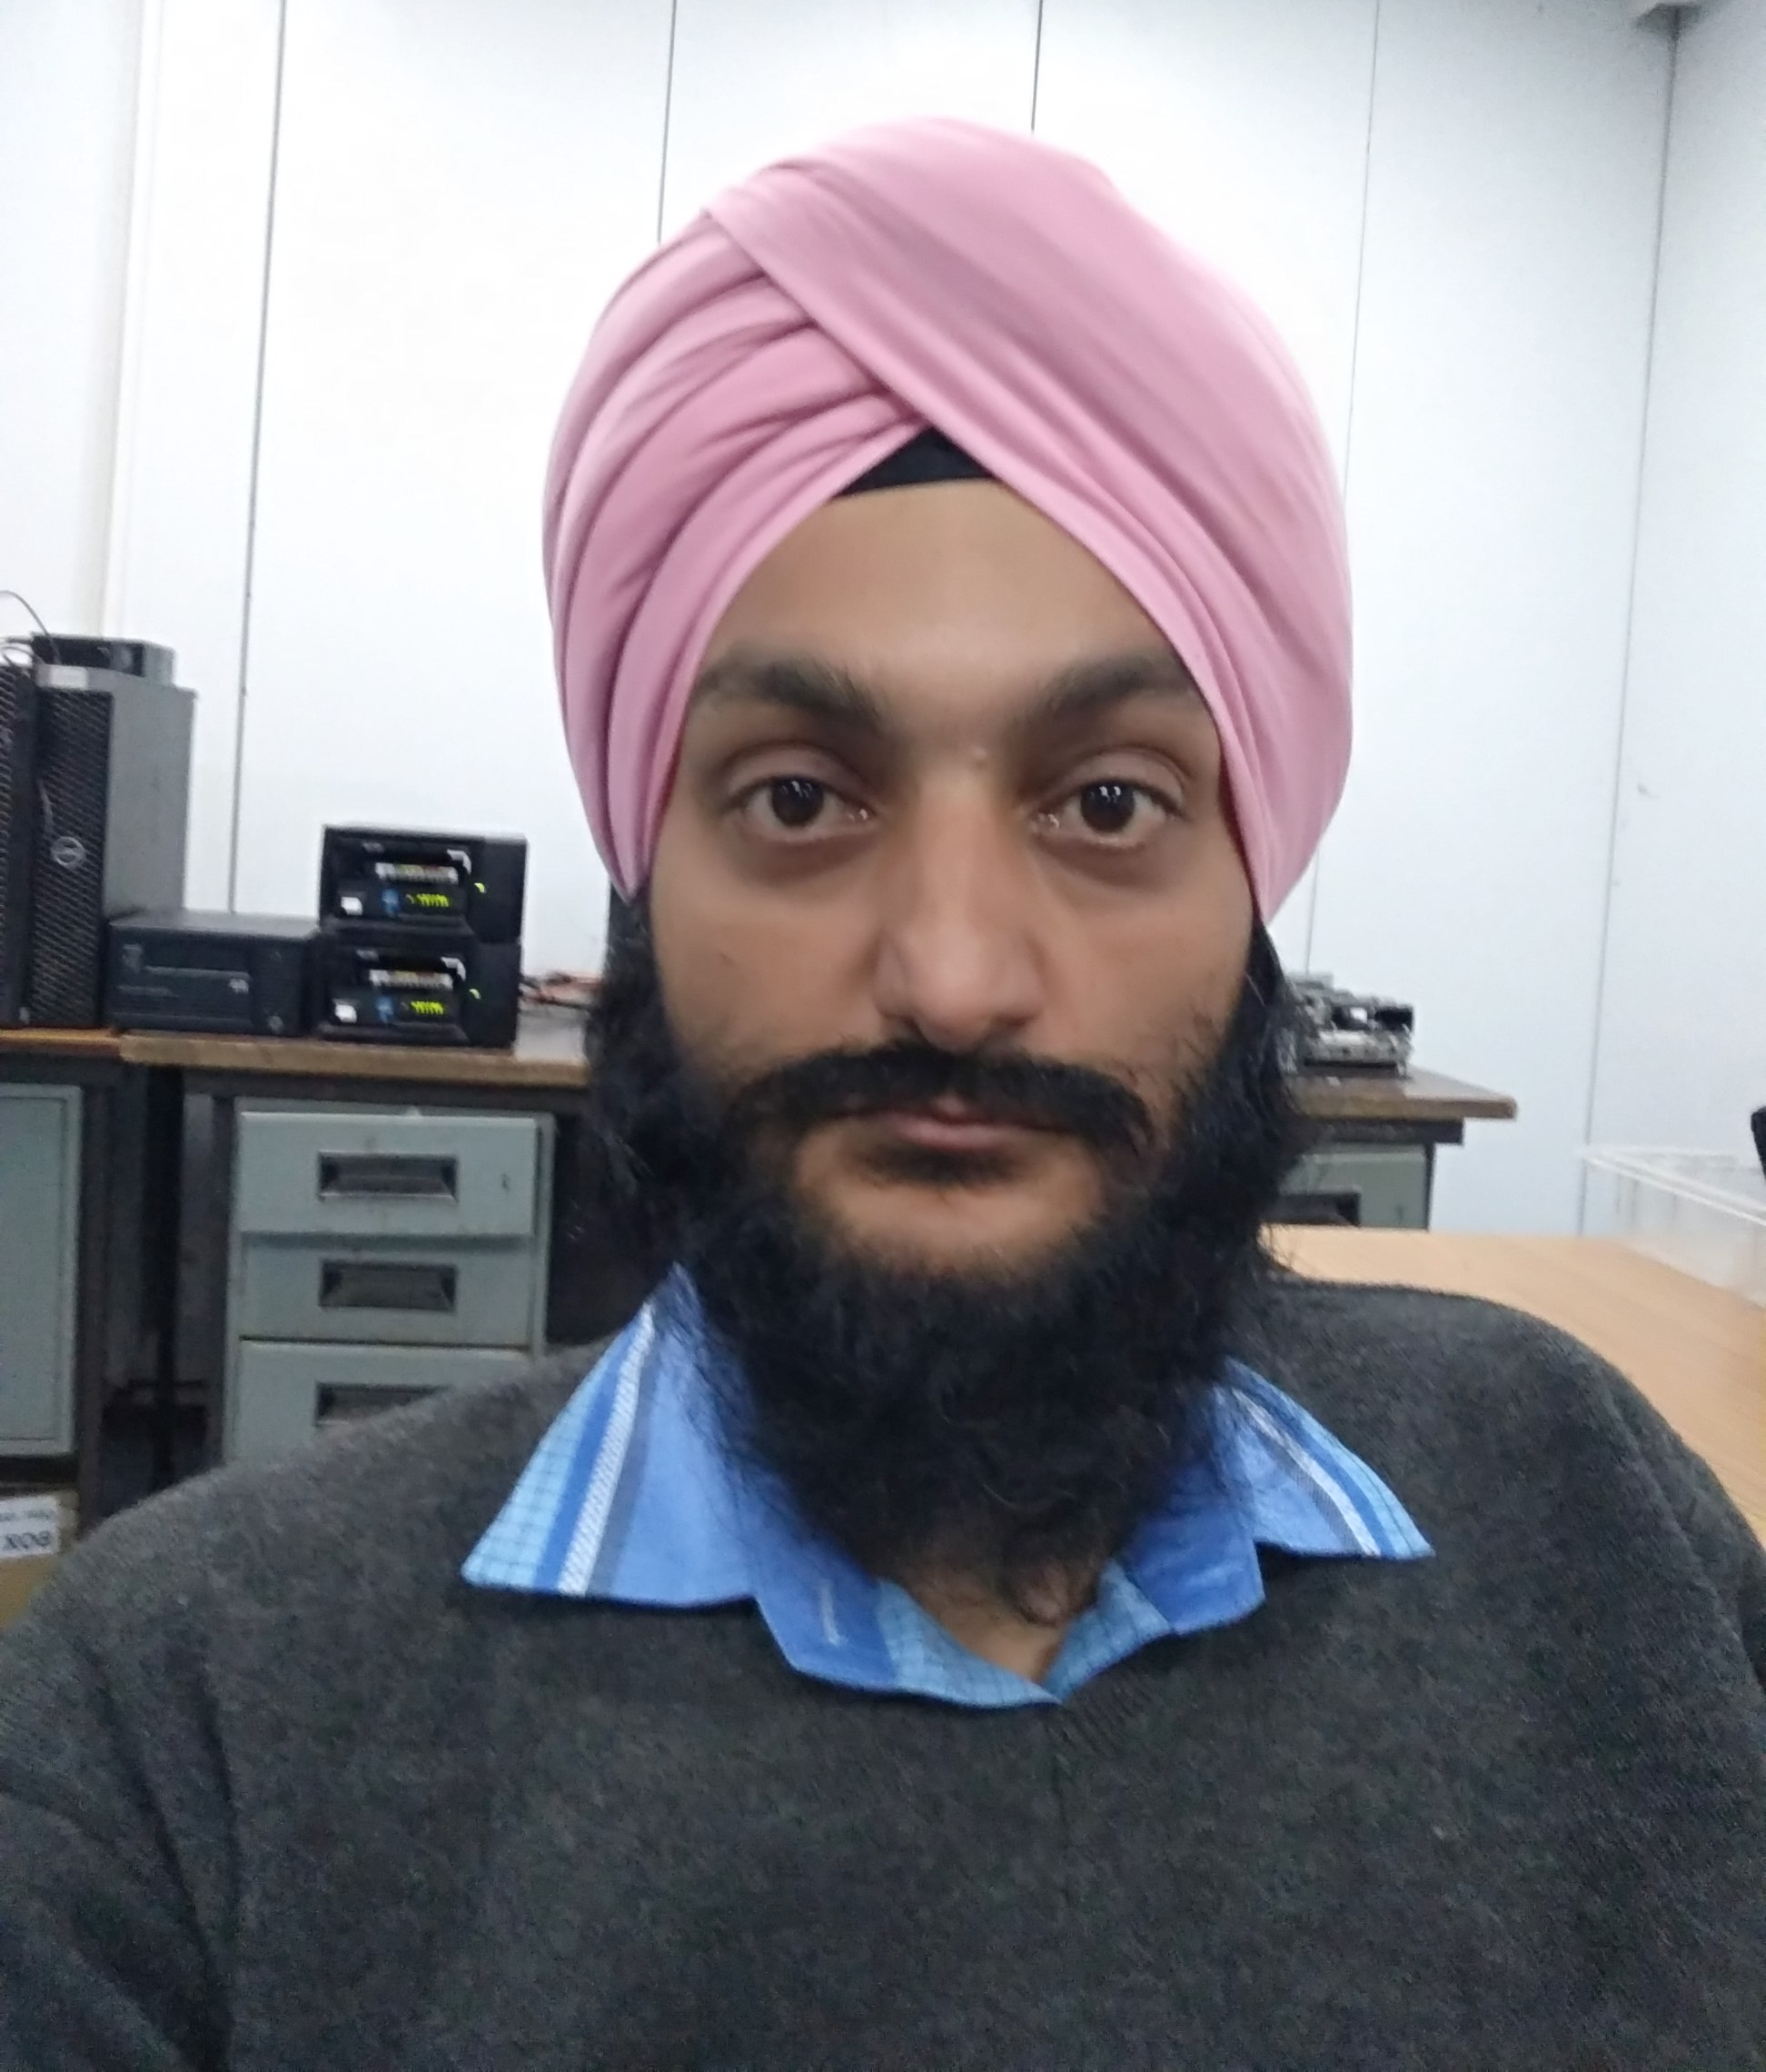

AMAR SINGH
144, IDGAH, Dehradun. 248001
Phone: (+91) 9897-2289-23
Email: amar.singh13@gmail.com
Work Profile : www.amarwork1.blogspot.in

Objective

Seeking a career in an organization to actively contribute in the success and growth of organization by working in a position where I can successfully implement my experience & technical knowledge & further enhance it through constant hard work.

Work Experience

Pan India Consultants Pvt. Ltd.
Gurgaon, Haryana

Technical Section: Technical Officer (20/7/2020 –06/09/2021)
Responsibilities
- Working as Technical Officer handling the Geopic data Recording information on Mac Operation System at ONGC, Geopic Centre, Dehradun.

The Pestle Weed International School
Dehradun

Administration Section: Office Assistant / Graphic Designer (1/2019 –7/2020)
Responsibilities

- Working as Office Assistant handling the filing system, Recording information, Updating paperwork, maintaining documents and word processing.
- Helping organize and maintain office common areas.
- Performing general office clerk duties and errands.
- Working as Graphic Designer handling the all internal designing work under the tight deadlines.
- Design using Corel Draw X6, Adobe Photoshop CS6 designing different kind of books, magazines, Newsletters, Logo, banners, Artwork & all other office admin works.

Hindustan Media Ventures Ltd,
Dehradun

About the Organization: The Company was incorporated on July 9, 1918 under the Indian Companies Act, 1913 as a public limited company under the name 'The Behar Journals Limited' and received the certificate of commencement of business on January 14, 1919. On November 17, 1987 the name of the Company was changed to 'Searchlight Publishing House Limited' to reflect to make the name of the Company more in consonance with its publication, 'Searchlight'. Subsequently, the name of Company was changed to its present name 'Hindustan Media Ventures Ltd.' to reflect the expanded business activities intended to be undertaken by the Company and to be in consonance with the prevailing industry trends and a fresh certificate of incorporation to this effect was issued on November 11, 2008.

Adops (Ad Operation) Section: Graphic Designer (04/2017 –11/2018)
Responsibilities

- Working as Graphic Designer handling the all advertisement work under the tight deadlines.
- Design using Corel Draw X6, Adobe Photoshop CS6, Quark Express designing different kind of books, magazines, Newsletters, Logo, banners& Artwork etc.

Lal Bahadur Shastri Academy of Administration
Mussoorie

About the Organization: The Lal Bahadur Shastri National Academy of Administration (LBSNAA) is India’s premier institution dedicated to training Officers of the country’s higher civil services.

Computer IT Section: Graphic Designer (01/2013 –03/2017)
Responsibilities

- Working as Graphic Designer handling the graphic work with a team of 7 people under me as well as collaborating with the printing dept. for any assist
- Managing & collaborating with the team to finish all work under the deadlines
- Design using Corel Draw X6, Corel Paint shop, Indesign and Adobe Photoshop designing different kind of books, magazines, brochure, leaflets& logos etc
- Hands on experience on several different formats of graphic designs including magazines, educational books, online banners, brochure & leaflets/flyers, ads, etc
- Communicated corporate identity through design of logos & collateral for Sargam – LBSNAA, National Centre for Sustainable Community Systems (NC-SCS), National Centre of Leadership Development and Competency Assessment (NC-LDCA)

Dainik Jagran
Dehradun

About the Organization: Dainik Jagran is the flagship brand of the company. In today’s dynamic media world, where consumers have an unprecedented array of choices, Dainik Jagran stands out as a brand that is the choice of millions of Indians as they start their day.

Advertisement Dept.: Graphic Designer (01/2008 –12/2012)
Responsibilities

- Heavily involved in the Daily Newspaper advertisement designing including the weekly magazines, banners & hoardings etc
- Managing a team of 5 people to beat all the deadlines also handling the work of proof reading
- Design using the software Corel Draw, Adobe Photoshop, Quark Express, Page Maker
- Have good typing speed in Hindi & English Key board 45/50 wpm

Wave India
Dehradun

About the Organization: Wave India Magazine, Estd. in year 2006. Its a monthly hindi magazine, Its a dehradun based magazine. Its a most faithful magazine in politics and crime which shows the real depth stories of the incident. There are several sections in Magazine like Politics, Business, Industries, Market, Sports, Stories, Films, Poems, Articles Editorial and much more.

Computer Section: Graphic Designer (04/2006 –12/2007)
Responsibilities

- Designing Magazine layout, Image Corrections & on several different formats of graphic designs including magazines, educational books, online banners, brochure & leaflets/flyers, ads
- Correction/Editing in the content provided from the clients

Achievements:

- Done a 3 days professional photography course in LBSNAA, Mussoorie

Skills

Computer Skills:

- Have an extensive experience on Windows 8, Windows 7, Vista, etc.
- Have a working knowledge Microsoft Office

Designing Skills: Have a working Knowledge of following software:-

- Corel Draw, Corel Photo Paint, Adobe Photoshop, Indesign, Adobe Illustrator, Quark Express, Adobe Page Maker, AutoCAD

Personal information

Strength
- Fun-loving, Enthusiastic, Trustworthy, Respectful, Tolerant, Practical
- Believe in team work & new ideas
- I am much confident about myself before and while pursuing a job.

Interest
- Prolific learning & growth
- Meeting people who are enriched with knowledge and experience

Education

Certified Course in Desktop Publishing & Web Designing(6 month)
- CADD Home, Dehradun (2005)

Two year Diploma in Modern Office Management & Secretarial Practice (73%)
- Govt. Polytechnic. Dwarahat, Almora (2003)
One Year Apprenticeship
- Aerial Delivery Research & Development Establishment (Ministry of Defense) Agra Cantt. (U.P.) (From 1st Dec.2003 to 30th Nov.2004)

Shri Guru Nanak Public Boy’s Inter College, Dehradun
- Intermediate
- High School

AMAR SINGH

