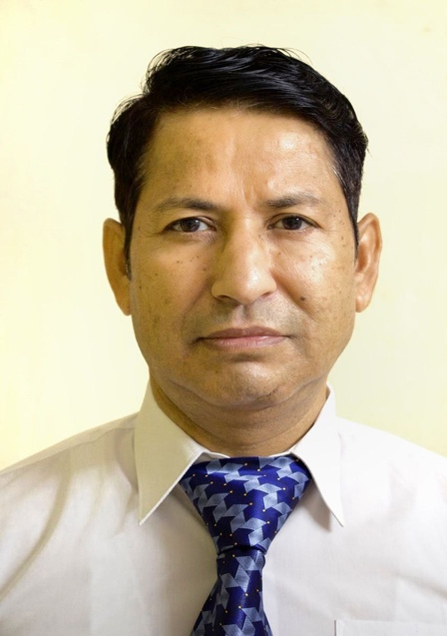
CURRICULUM VITAE
PRADEEP KUMAR RAWAT
SENIOR ENDOSCOPY TECHNICIAN
Mobile No.- +919910675585
Email-gastropradeep@gmail.com

- OBJECTIVE
To work in a progressive team environment to gain experience by implementation of my knowledge and get maximum exposure while working to the best of my belief and concern for the betterment of the mankind.

- EDUCATIONAL QUALIFICATION

Educational Qualification | Year of Passing | Board/University
High School | 1991 | CBSE
Higher + Senior Secondary | 2001-2003 | CBSE
Endoscopy Training  (1 year) | 2010 | Sir Ganga Ram Hospital
Diploma in Endoscopy Technician | 2012-2014 | M.S Paramedical Science  (Ghaziabad U.P)
BASIC LIFE SUPPORT | 2025 | AMERICAN HEART ASSOCIATION

- TECHNICAL TRAINING & WORKSHOP

- Training of endoscopy technician in ALL INDIA INSTITUTE OF MEDICAL SCIENCE New Delhi.

- Technician Engagement Training conducted by OLYMPUS Medical System India Pvt. Ltd.

- Technician Training Workshop held by BOSTON SCIENTIFIC.

- Technician training program from BLK Super Specialty Hospital, New Delhi.

- One month training in various ERCP and Endoscopy related procedure at GB Pant Post Graduate Hospital, New Delhi.

- Endo - 2017 world Congress of G S Endoscopy
WEO - Training program, Hyderabad
- Endo - 2017 Boston Scientific Technician Training program, Hyderabad

- Basic and Advance Therapeutic procedure training program at Sir Ganga Ram Hospital, New Delhi.

- PROFESSIONAL EXPERIENCE

- Assisted doctor in Endoscopy procedures in a variety of settings. Including care unit, Operation Theatre and Endoscopy unit.
- Collected specimens from patient using standard medical precaution.
- Setup and teardown of all equipment.
- Prepare patient for the procedure.
- Prepare suits according to endoscopic procedure requirement.
- Kept facility stocked with necessary supplies, equipment and apparatus.
- Comforted patient and providing them with reassurance and encouragement.
- High Quality Disinfection of Endoscope and accessories by manually and mechanically.
- Monitor patient’s condition and maintain accurate documentation, pre- procedure, during procedure and post procedure.
- Responsible for maintaining the instrument and equipment and reporting when malfunctioning is noted.
- Perform safety checks to check proper equipment functioning.
- Expertise in the area of managing bleeders.
- Proficient at assisting advanced therapeutic procedure (ERCP, CBD and Pancreatic Stone removal & Stenting of CBD).
- Proficient in using all latest in field is Single Balloon, Double Balloon, EMR (all Com. accessories).
- Working with minimal supervision during endoscopic procedure admission and recovery of patient and other related procedures.

- WORK EXPERIENCE

    - Organization PGIMER & Dr. Ram Manohar Lohia Hospital, New Delhi in Department of Gastroenterology w.e.f.2004 to 2017, March.
    - Two years experience in All India Institute of Medical Sciences on Deputation New Delhi India.
    - I have worked in JCI accredited Al Ahalia Hospital, Abu Dhabi, UAE, from 20 April 2017 to 12 March 2018.
    - I have worked in JCI accredited International Modern Hospital, Al Raffa area Dubai, UAE from 2 Aug to January 2021.
    - I have worked in a Sr. Technician in the Department of Gastroenterology NABH accredited Vimhans Nayati Super Specialty Hospital, Nehru Nagar, Delhi,from 1 january 2020 to 21 july 2020.
    - Currently working in the Department of Gastroenterology, JCI accredited Prime Hospital, Al Garhoud Road, Dubai, UAE from 24 july 2020 to till date.

- KEY RESPONSIBILY AREA

Assisted in all type of procedure i.e. ERCP, ESD, APC, EST, EVL Polypectomy, EMR, Achalasia Cardia Pneumatic Dilatation, Upper GI/ Lower GI Endoscopy, Single Balloon Enteroscopy, Hemoclip Application, Sclerotherapy, Glue, Injection, SG Dilators & CRE, All Stenting, All Ballooning, PEG, Cystogastrostomy, EUS guided ERCP.

SIGNATURE

(PRADEEP KUMAR RAWAT)

Dated:

