RESUME

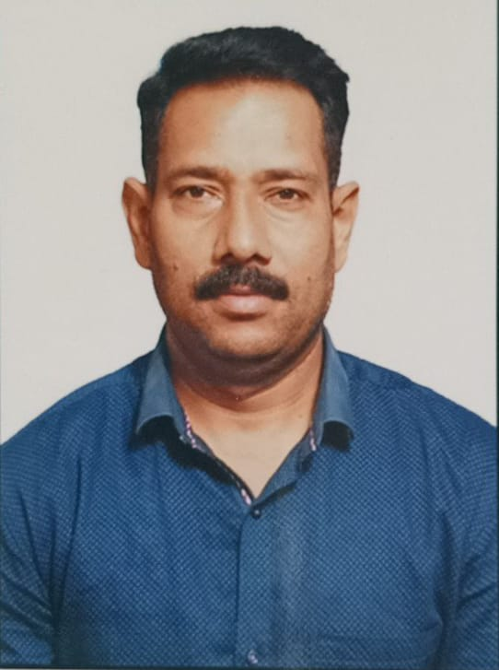

SURESH S. NANANDAGE

Career objective:

To work in challenging and dynamic environment and to keep adding value to the organization that I represent and serve, while also concurrently upgrading my skills and knowledge.

Academic Qualifications:

Examination | School /College | Board/University | Year | Result
SSC | SEDSHAL ENGLISH SCHOOL | SHIVAJI UNIVERSITY | 1992 | 71%
HSC | BAPUJI SALUNKHE COLLEGE | SHIVAJI UNIVERSITY | 1994 | 56%

Professional Qualification:

Examination | Name of University | MODE | Year | Result
DIPLOMA IN PHARMACY | STATE PHARMACY COUNCIL MUMBAI | REGULAR | 1996 | 73%
BBA | SIKKIM MANIPAL UNIVERSITY | DISTANCE | 2016 | 62%
PGDM (HCM) (HB) | PRIN. WELEINGKAR INSTITUTE OF MGT DEVELOPMENT AND RESEARCH | HYBRID | 2021 | 70%

WORK EXPERIENCE:

- Served in Indian Army for 24 years as Medical Assistant.
- Worked as Nursing commander of different medical groups.
- Presently working as Assistant Nursing Superintendent in
Ushahkal Multispeciality Hospital, Damani Road, Sangli.

INDIVIDUAL ACHIEVEMENTS:

- Good communication and presentation skills.
- Can converse in English, Hindi, Marathi, and Kannada
- Comfortable with long physical activities.

COMPUTER PROFICIENCY:

- Proficiency in Microsoft office and windows (MS-CIT)
- Working experience in different software module of Hospitals.

PERSONAL INFORMATION:

ADDRESS:-

FLAT NO. 102, MORAYA APPT.
SANGLI, MAHARASTRA
PIN: 416416
CONTACT NO: 7507573635
E MAIL ID: nsmadyman@gmail.com
Fathers Name: S R Nanandage

- Date of Birth: 20 Aug 1976

DECLARATION
I hereby declare that all the above-mentioned information is true to the best of my knowledge and belief.

Place: XXX
Date: Suresh Nanandage

