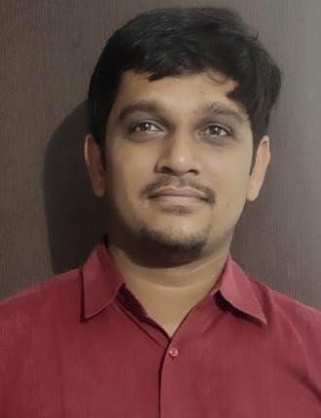
DHAVALPARMAR

Address: D/52, 501, Swaminarayan Park,
Opp. Panacea Residency, Vasant Vihar road, Naroda, Ahmedabad. 382330

Contact No.: +91 8469381115

Email ID: dhavalparmar605@gmail.com

CAREEROBJECTIVE

To secure a challenging position in a reputable organization to expand & share my learning’s, knowledge & skills learnt during my work experience. To secure a responsible career opportunity to fully utilize my training and skills, while making a significant contribution to the success of the company/organization in accordance with customer satisfaction.

EDUCATIONALQUALIFICATIONS

DEGREE | BOARD / UNIVERSITY | PERCENTAGE | YEAR
APGDEC | Osmania University | 72% | 2019
B.Sc (Chemistry) | Saurashtra University | 62% | 2012
HSC(Science) | GSEB | 58% | 2009
SSC | GSHSEB | 72% | 2007

LITERACY /SKILLS

- Good knowledge about MSExcel
- Good knowledge about MSWord
- Good at Pre-Hospitalcare
- Good at Psychological knowledge &counseling
- Good in sharing knowledge of my skills to otherEMT’s
- Good in sharing feedbacks with concerned team or agent for the areas ofimprovement

EXPERIENCE

Total Work Experience:- 8 year 5 month

- Currently working with GVK EMRI, State Emergency Response Centre for Gujarat State asa Officer with Quality Department (Dec’20 to tilldate)

Job profile includes:-
  - Good knowledge of IV insertion
  - ECG
  - RT
  - Uro catheterisation
  - ET tube
  - Patient care
  - Documentation about patient care
  - Vital monitor effective way
  - Good in assisting all medical procedure
Other Experience includes:

- Worked as a Basic EMT & Advanced EMT with GVK EMRI from (Dec’13 toOct’16)

Job profile includes:-
  - Pre-Hospital care to be given tovictim/patient
  - Documentation of care given tovictim/patient
  - Proper handover of patient to hospital & police staff whereverrequired
  - Maintaining ambulance & stock of medicines utilized during themonth
  - Analysis of usage of medicines & preparation of demandaccordingly

INDEPENDENT PROJECTSCOMPLETED

I have availed practical experience during my study for Advanced EMT.
- A project based on research for the cases related to Snake bite & the treatment to beprovided in suchcases

AWARDS/ACHIEVEMENTS/PARTICIPATIONS

- Awarded District Saviour Award with GVK EMRI for Rajkot district for handling case of cord aroundneck
- Awarded EM Care Award with GVK EMRI for Mahesana district for handling case of SnakeBite

PERSONALDETAILS

DateofBirth : 10thNovember,1991
Gender : Male
Nationality :Indian
Marital Status : Married
LanguageKnown : English, Hindi &Gujarati
Strengths : Hard working, sincere, team player, ability to train and manage a team,smart decision making capabilities, eager to learn & a fastlearner

I declare that the above information furnished by me is true to the best of my knowledge and will present original document whenever asked for.

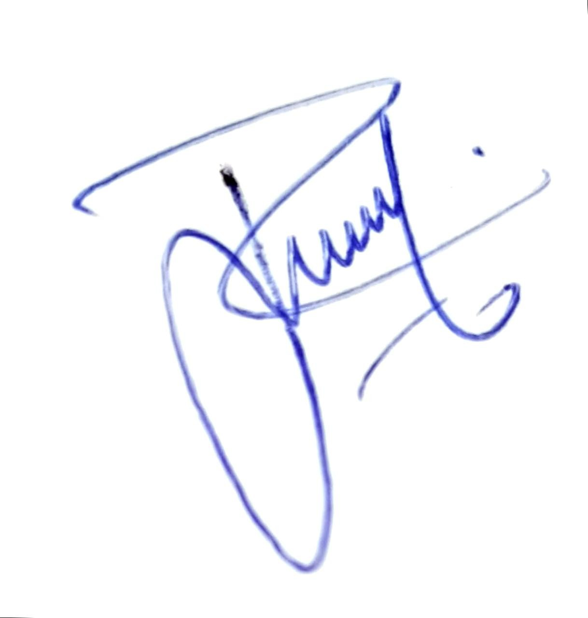
Withregards,
DhavalParmar

