RESUME
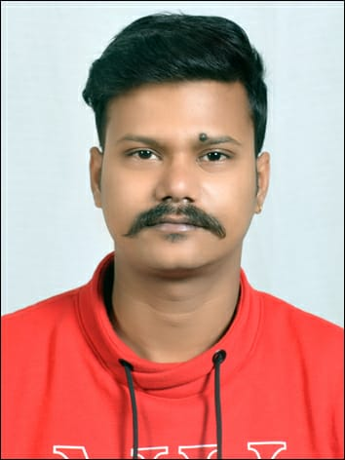
OBJECTIVE:-
Be a Medical Technologist with a good laboratory to build and utilize skills in testing different techniques and methodologies.

AREA OF INTEREST: - Medical Technology

PERSONAL DETAILS:-

Name : Subhajit Sarkar

Address : Flat No. 303C, 1st Floor, Ganesh House-1,
Rupnarayanpur Bazar, P.S: Salanpur, West Bengal-713364

Cell : 9434628058 / 7908561485
Email : subhajitsarkar48@gmail.com
Gender : Male
D.O.B. : 21st April 1994.
Nationality : Indian
Strengths: I am hard-working and goal-oriented man. I love to face challenges and believe that "Strategic Planning" is the key behind every success
Interest & Hobbies : Cooking, Traveling, Music, etc.
Languages Known : Bengali,English, Hindi
Marital Status : Single
WORK EXPERIENCE
- As a marketing Executive In Brainware From March 2014 to March 2015
- Work as Trainee from 23rd March 2017 to 15th July 2017 in Avishkar Diagnostic,Asansol, West Bengal. (all types of X-Rays including Special Cases)
- Working in Krsnaa Diagnostics Ltd. as a CT Scan Technician and also Center Manager from 1st April 2018 to 19th October 2022
- Working in healthMap Diagnostics Pvt.Ltd as Sr.CT Scan Technician from 26th October 2022.

EDUCATIONAL QUALIFICATION

Course | Board/ Collage | Year of Passing | Division/ marks
10th Standard | W.B.B.S.E | 2012 | 2nd
12th Standard | BBOS | 2022 | 1st
ITI (Electrician) | Chittaranjan Pvt. ITI (NCVT) | 2016 | 84.96%
Diploma in Radiology and Imaging Technology | Sanjeevni Institute of Paramedical Sciences | 2018 | 87.88%

CURRICULARACTIVITIES:-

- Equi Diploma in Software Programming from Brainware Computer Academy.
- Knowledge in Computer [(MS Office 2007, Linux, C Programming, C++, MS Access, VB.Net, Core Java, Advance Java and Micro Java)].

I hereby declare that all the information mentioned above is true and correct to the best of my knowledge.

Date: __/__ /202_

Place: Rupnarayanpur (SubhajitSarkar)

