RESUMÉ
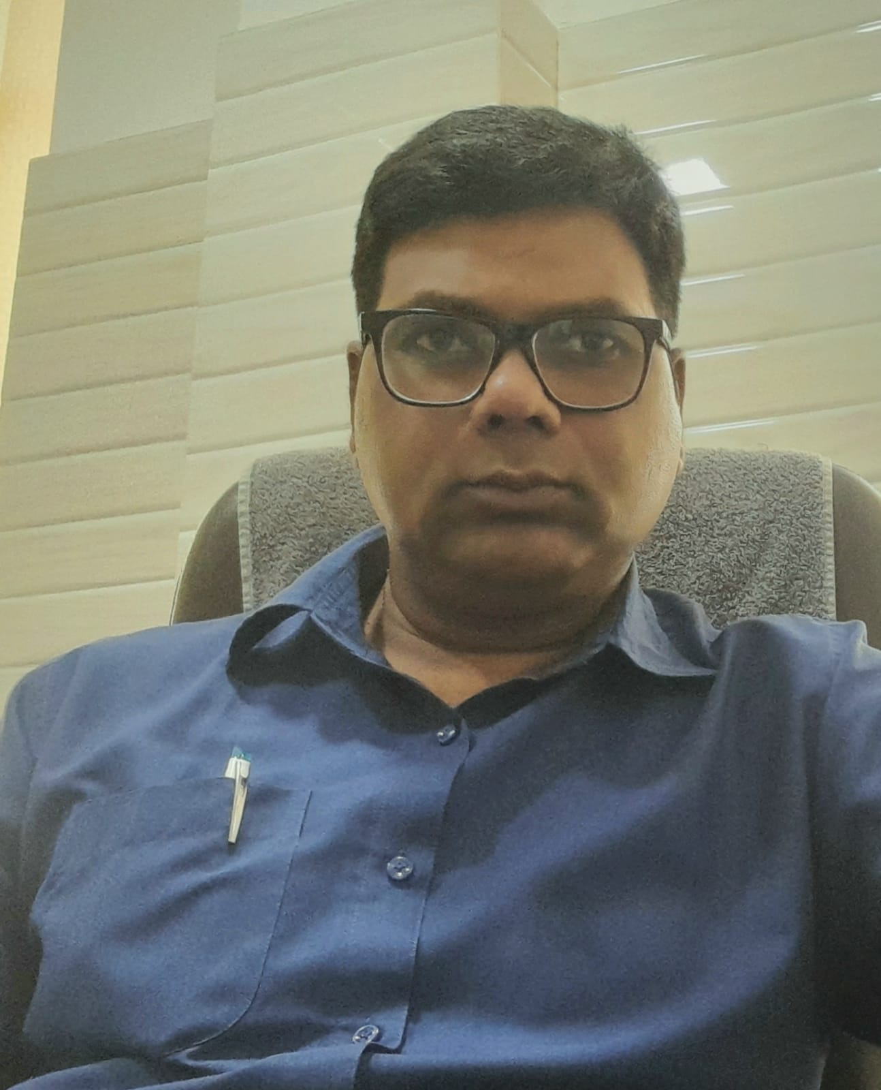
Dr. Emanuel Sanjay Nanda
B.Sc, MBBS, DCH [CMC-Ludhiana]
PG Diploma in Hospital Management
MBA (HR)
PG in Leadership and Management [ISHA]
Work Exp: 18+years
Mobile: 8859644268
E-Mail: senanda@rediffmail.com
MCI Reg. No – 23861
UK Reg. No-7929
DOB: 13th July, 1970

Career Objective
- To learn, contribute and grow with the growth of the organization.

Core Competences
- 18+ year’s professional experience as pediatrician.
- 8+ years experience in an administrative role as Director/Med.Supt.
- Active contributor towards activities required for the growth of an organization.

Key Attributes:
- Honest and industrious by nature, believe in taking up challenges and executing work at hand with great felicity.
- Ability to handle multiple tasks at a time.

Special Achievements:
- Member of emergency relief team (Jan-Apr 2001) for the earthquake victims in Gujarat.
- Medical officer tuberculosis control (MOTC) for Sate TB control society UP (for 1 yrs).
- Participant in International Conference on Global connection on Health, in Washington and Baltimore (USA).
- Visited BRAC (largest NGO in the world) in Bangladesh to see their working and business module.

Professional Particulars:
- 1999-2001
Diploma in Child Health Care from CMC Ludhiana (Punjab University)
- 1991-95
MBBS from CMC Ludhiana (Punjab University)

Educational Qualifications:
- 1987-1990
Bachelor of Science from St. John’s College, Agra University
- 1987
Senior Secondary from St. John’s College, Agra
- 1985
Matriculation from St. Peter’s College, Agra

Employment History:
Total Work Experience: 18 years

Work Experience:

PROFESSIONAL EXPERIENCE:
DESIGNATON | INSTITUTION | DURATION
- EMO | Clara Swain Mission Hospital(200 bedded hospital), Bareilly, U.P | Feb 1997 - Jul 1999
- Jr. in Dept (Gen. Surgery) | CMC Ludhiana, Punjab | Jul 1999 - Dec 1999
- Pediatrician | Clara Swain Mission Hospital, Bareilly | Feb 2002 - Jan 2003
- Consultant Pediatrician | - Swarn Jayanti Hospital(75 bedded multi specialty hospital), Mathura, U.P  - Jivadhara Institute of Neurodevelopment and Research, Kochi, Kerala  - PARK Hospital (250 bedded multi super specialty hospital), NCR  - Pediatrician(Private Practice), Mathura, U.P  - St. Paul’s Hospital, Dehradun  - Medicare Multi Specialty Hospital, Dehradun | Feb 2003 – March 2013  April 2014 – March 2015  April 2015 – Sep 2015  2015 – 2018  April 2018 - June 2021  Presently

ADMINISTRATIVE EXPERIENCE:

DESIGNATION | INSTITUTION | DURATION
Deputy Director | Swarn Jayanti Hospital, Mathura | Oct 2005 – Oct 2006
Associate Director | Swarn Jayanti Hospital, Mathura | Nov 2006 – March 2008

REFERENCES:

- Prof. Alok Mathur
Dept. of Surgery, Inderash Hospital, Dehradun
7017270309

- Mr. Sarfaraz Ahmed
Administrator, Jindal Hospital, Hissar
9996788283

