CURRICULUM VITAE
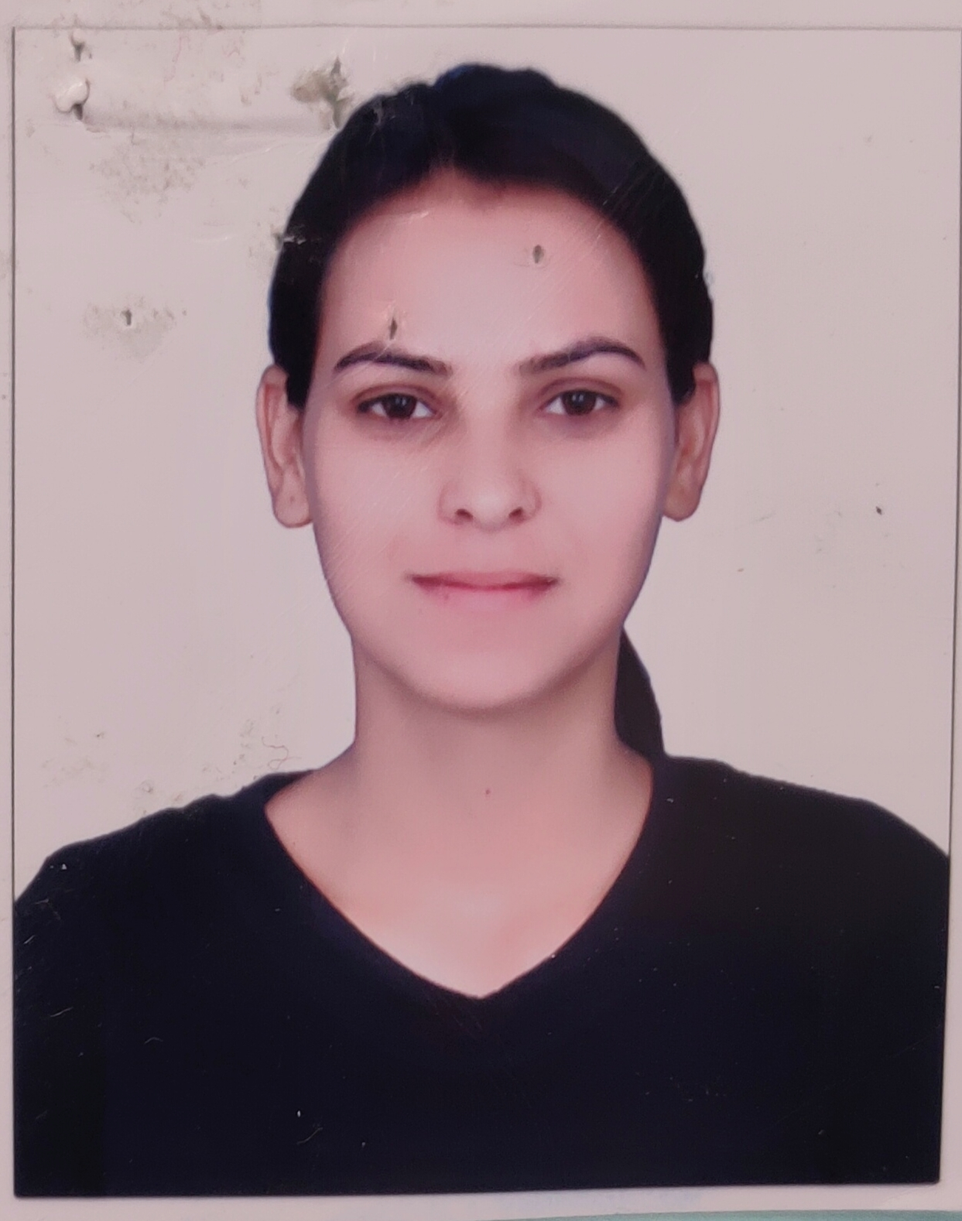
SHRISHTI SAKLANI

100,Hill view colony
Indranagar, Dehradun
Uttarakhand – 248001
Email:-shrishtisaklani04@gmail.com
Contact (M):-8394986955

CAREER OBJECTIVE:-

To secure a challenging position in a reputable organization to expand my learnings, knowledge, and skills.

QUALIFICATIONS:-
- 10TH Pass out with CBSE Board2014
(SGRR PUBILIC SCHOOL DEHRADUN)
- 12TH Pass out with CBSE Board 2016
(SGRR PUBILIC SCHOOL DEHRADUN)
- B.com
(IGNOU UNIVERSITY)

4 YEARS EXPERENCE:-
1. Regenta lP vilas as a front office assistant ( 1 year )
Job responsibilities- To maintain the all documents of the front office, mails, check out-check in,billing and handling the costumers.
2. Bubble pre school as a Coordinator ( 1 year )
Job responsibilities- To maintain inventory, Dealers and maintain the financial records of the all School Franchise of Dehradun.
3. Balajee Sewa Sansthan currently working as a Admin and Accountant From last 2 Years.
Job responsibilities-To maintain the Inventory, Dealer and distributors ledgers,Cash ledger, Cash handling, Documentation,Vouchers,Salary,Emails,Sale biling,Making payment,PFMS,SIMS,Tally ERP 9,Bank reconciliation, Website handling, Follow up of department ,Tentative Plan of workers, Update the monthly reporting of the projects in state level.

KEY SKILLS:-

- Data Reporting
- Data Summarizing
- Basic Computer knowledge
- Tally 9 ERP accounting software
- PFMS (Public Financial Management system)
- SIMS (Strategic Information Management System) State level reporting.
- MS Excel
- MS Word
- Power Point
- English Typing

Personal Skills:-

- Honest
- Disciplined
- Hard-working
- Innovative
- Good Communication Skills

PERSONALINFORMATION:-

FATHER’SNAME :Mr. Satish Saklani
MOTHER’SNAME :Mrs. Indu Saklani
DATE OF BIRTH :17/11/1998
GENDER :Female
MARITAL STATUS :Unmarried
LALNGUAGES KNOWN :Hindi, English
NATIONALITY :Indian

I hereby declare that the above written particulars are true to the best of my knowledge & belief.

Signature:- Date:-
Place:-

