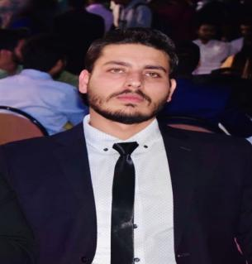CURRICULUM VITAE :

Dr. Ranveer Singh
Email - ranveersinghx1@gmail.com
Phone no.- +918077649839

CAREER OBJECTIVES :
Seeking for opportunity to work as medical professional in a reputable hospital and utilize my professional skills to improve client satisfaction for the benefit of the organization.
EDUCATION DETAILS :
10th and 12th from Shamli (U.P)
Bachelor of Medicine and Bachelor of surgery (MBBS) from University of National research Ogarev Mordovia state university (saransk) Russia .with Distinction ( 2016 - 2022)
FMGE(MCI) passed 2023 in first attempt with 191 marks

WORK EXPERIENCE : Gautam buddha chikitsa mahavidyala (subharti hospital), dehradun
1 year compulsary rotatory internship finished on may 2024
Have experience of working in Covid ward in university hospital
Handled as :
Assisting the senior doctor in checking patients.
Diagnosing the disease as per symptoms.
Observing and performing the examination of samples for disease diagnose. Learning the diagnostic method and equipment’s.
In case of emergency giving the basic treatment to the patients.
Helping other medical staff in performing their duties.
KEY SKILLS :
Knowledge of medical terminology.
Can handle the patients .
Observed major surgeries ( Lap cholecystectomy, Modified Radical mastectomy, ACL reconstruction, Diabetic foot amputation,maternal delivery,gynecology procedures)
CERTIFICTIONS: Basic life support(BLS)
CPR and AED program
ACLS

