PRASHANT SHARMA
Contact: -+918081616656, 8445943554 |Email Id: Sharmaprashant7800@gmail.com

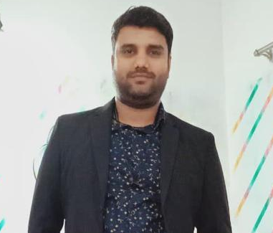  Permanent Address :  PRASHANT SHARMA  Moradabad (U.P.) |  | Career Objective
 |  | To work in an efficient and effective way on any task given, such that grow this substantial and results are far reaching.
 |  | About Me
 |  | I am a person who is fully optimistic, like to interact with people very much but also like to spend some time alone for introspection. However, my ability to stay calm and find solutions to problems, I enjoy working under pressure and lead by logic and with my high reasoning abilities.
 |  | Academic Qualifications
- Graduation from MJPRU.
- Higher secondary from MJPRU.
- High School from MJPRU.

 |  | Working Experience
- Working in presence
- Currently working with VIMS Gajraula as a TPA manager.
- 6 year experience as a part of TMU Hospital. As a Insurance and TPA MANAGER NOV 2017 TO 30 NOV 2023
- 5 Years’ experience in automobile sector as a sr. sales consultant.
- 3 Years’ experience sales executive in Dainik Jagran Bareilly.
Phone:

+918081616656, 8445943554

Email:  Sharmaprashant7800@gmail.com |  | Computer Skills
Email:  Sharmaprashant7800@gmail.com |  | - Excel, PowerPoint, Project, Word, Google Docs, Google Sheets, and Task Management.
Personal Profile:  D.O.B: 27 JUNE, 1993 |  | Interpersonal skills
Personal Profile:  D.O.B: 27 JUNE, 1993 |  | - Punctuality & Dedication  - Willingness to learn new things deftly.  - Disciplined &good etiquette.  - Logical Approach with Positive Thinking.  - Inter personal Skills Ability to rapidly build relationship and setup trust.  - Ability to cope up with different situations, self-motivator
Language Known:-

Hindi English
 |  | Area of Interest
 |  | - Managing the difficult tasks in every field.

Marital status:  Married  Hobbies Interest:  Travelling and watch all the social media account  Nationality: Indian | WORKING PROFILE  - Managing and accessing the work to team Government portal, TPA and Insurance portal. Preparing and handling the MIS related to all department, while preparing relevant analytics maintaining all Cases file & records. And last Submission of Daily & Monthly and Annual reports to the chancellor.
Date: 05/03/2024 PRASHANT SHARMA

